ASSIGNMENT: 1

- Draw a simple diagram (hand-drawn or digital) showing how your phone connects to Instagram, including your device, WiFi router, ISP, and Instagram server. Label each part and the connections
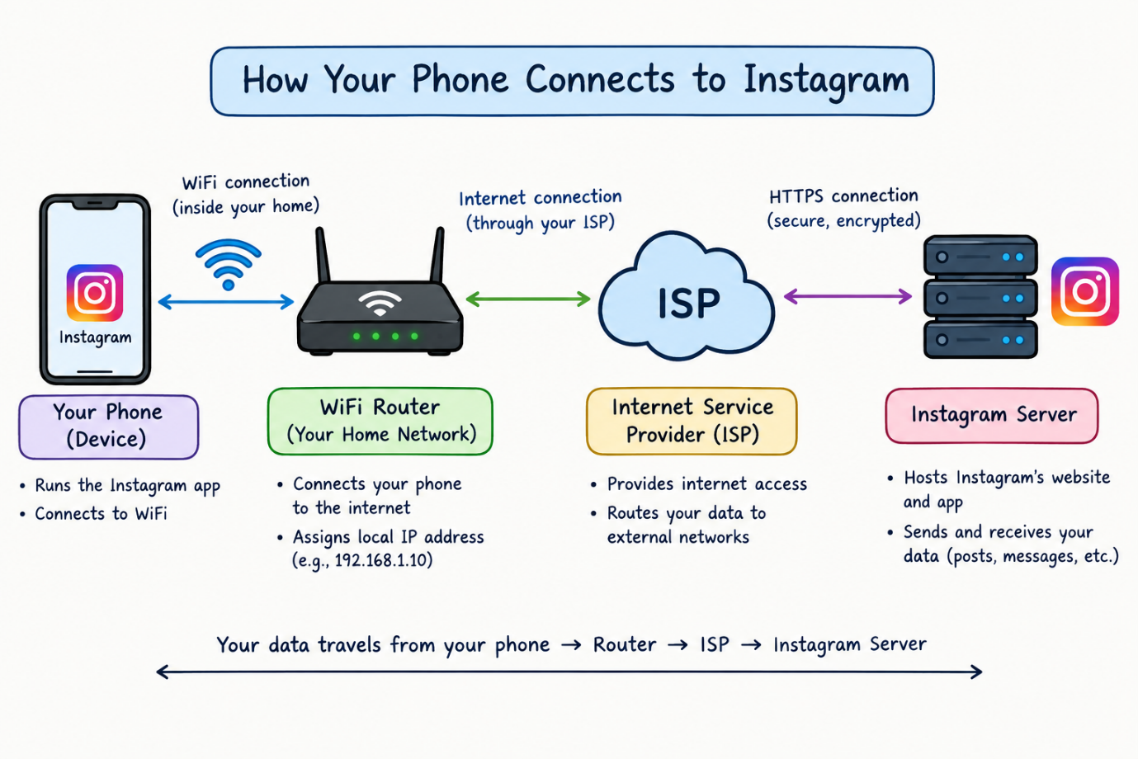

- List 5 devices you use or see daily that are part of a network (for example: smartphone, smart TV, WiFi router, laptop, smartwatch). For each, write what type of network it connects to (LAN, WAN, PAN, etc.).

No. | Device | Type of Network | Purpose
1 | Smartphone | PAN / WAN | Connects to other personal devices via Bluetooth and to the internet via mobile data.
2 | Laptop | LAN / WAN | Connects to a local Wi-Fi network and accesses the internet.
3 | Smart TV | LAN / WAN | Connects to Wi-Fi to stream online videos.
4 | Wi-Fi Router | LAN / WAN | Connects local devices and provides internet access.
5 | Smartwatch | PAN | Connects to a smartphone using Bluetooth.
Network types:
- LAN (Local Area Network): Connects devices within a limited area, such as a home or office.
- WAN (Wide Area Network): Connects networks over large geographical areas, such as the internet.
- PAN (Personal Area Network): Connects personal devices over a short distance, usually using Bluetooth.

- Explain the difference between the Internet and an intranet using an example from your college or a public WiFi you have used.
Difference Between Internet and Intranet

Internet | Intranet
The Internet is a worldwide public network. | An intranet is a private network used within an organization.
Anyone with an internet connection can access public websites. | Only authorized users can access the intranet.
Example: Google, YouTube, and public websites. | Example: A college's internal student portal.

- Pick any one app you use (like WhatsApp, Zomato, or Flipkart) and describe, in 4-5 lines, how data travels from your device to their server and back when you perform a search inside the app.<br><br><em><strong>Hint:</strong> Mention the devices and networks involved, and what happens when you hit 'search'.</em>

Example: Searching for a Product on Flipkart
- I open the Flipkart app on my smartphone, which connects to the internet through Wi-Fi or mobile data.
- When I type a product name and tap Search, my phone sends a request through the network to Flipkart's server.
- The request travels through routers and the Internet to reach the server.
- The server processes the request, searches its database for matching products, and sends the results back to my phone.
- My smartphone receives the data and displays the product names, images, and prices on the screen.

